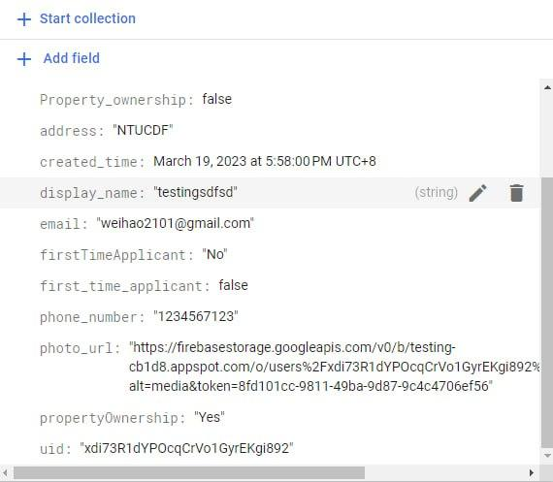

**LAB 3 DELIVERABLES DUE NEXT THUR**

1) Use case description: wei Hao

2) use case diagram: Jabez

3) dialog map: yupei

4) Class diagram**: glendon, jabez, yupei, wei Hao

5) System architecture: Bryan

6) Application skeleton: ALL

Guys I’ve created a document in Lab 3 folder on google drive for **application skeleton** as what yupei sent. Everyone just fill in your own parts doesn’t need to be v comprehensive I think. Rmbr to do y’all own parts too for the class diagram (UML) and Use Case. I think focus more on the documentation leading up to submission but the code need to get done asap cos we need to do **White box and black box testing** plus a bunch of other stuff. The demo is due next next week.